Azfar Ahmed Abbasi   
24k-2576  
Ds-1b  
PF LAB 9 September  
  
Question 1   
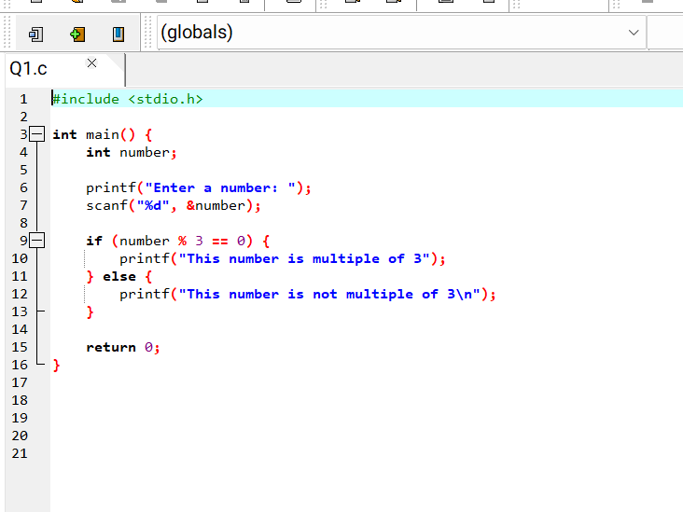

Question 2  
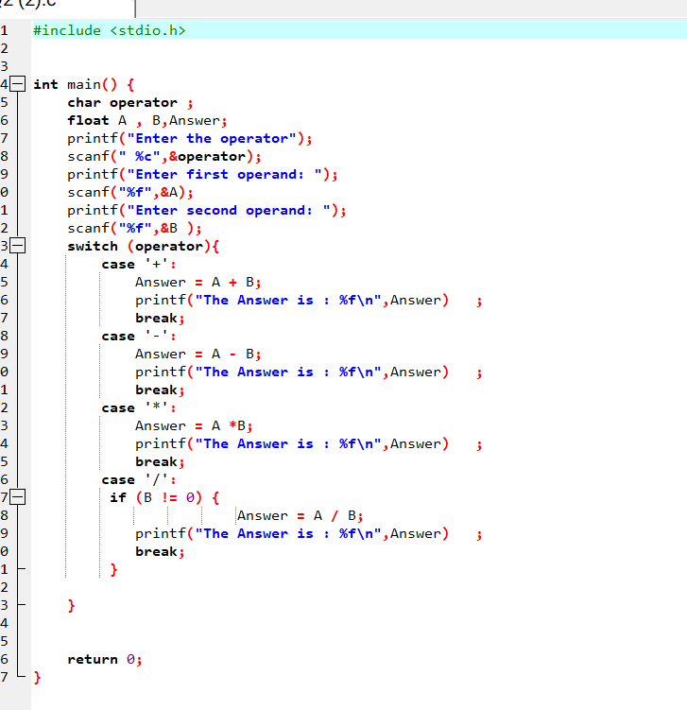

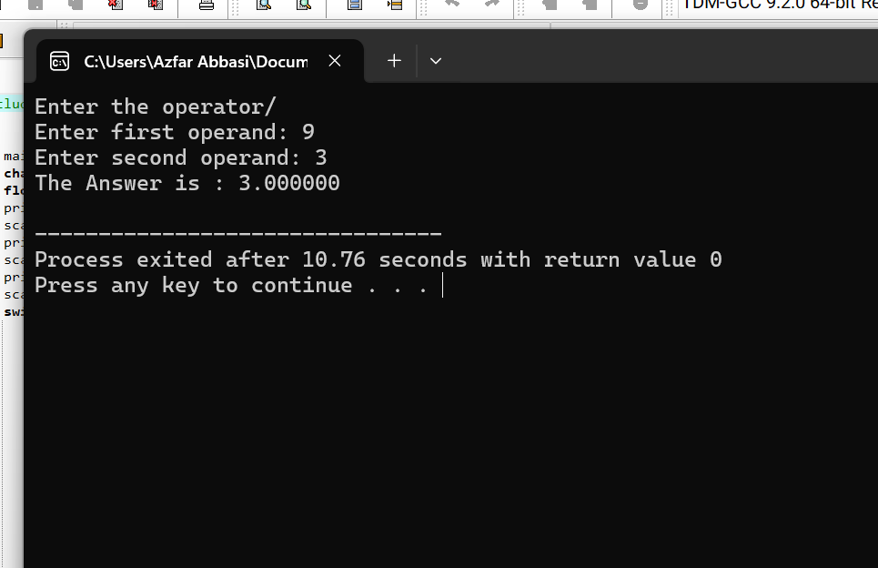  
  
  
  
  
  
  
  
  
  
  
  
Question 3

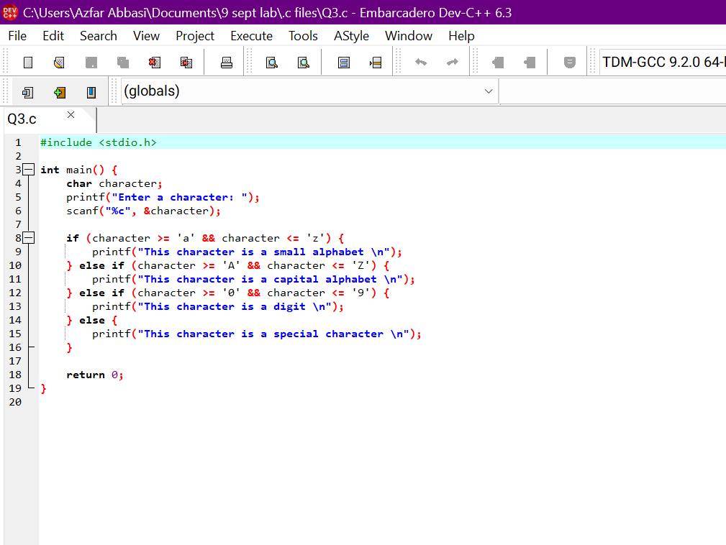

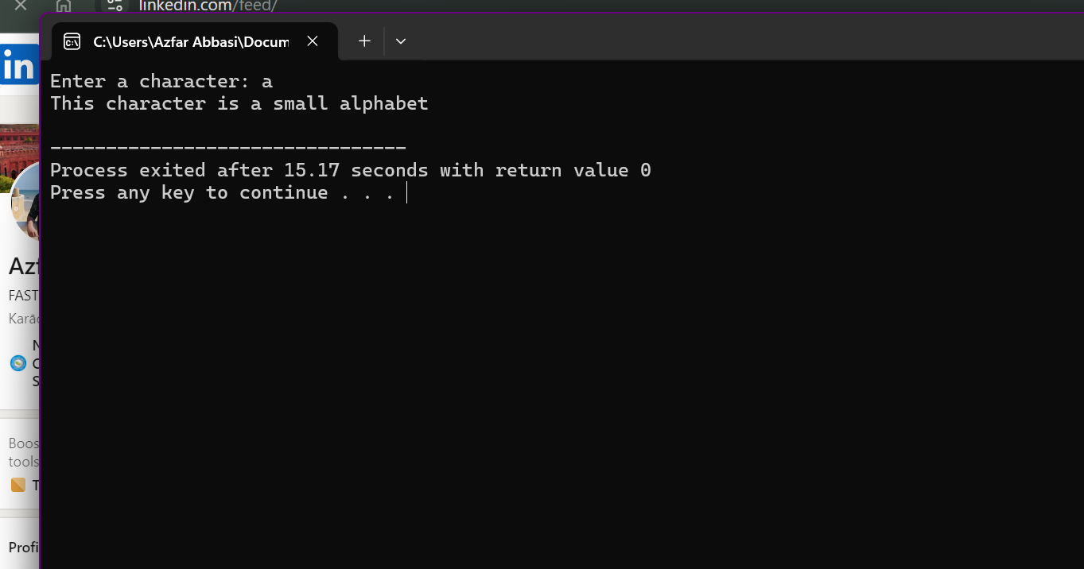

Question 4  
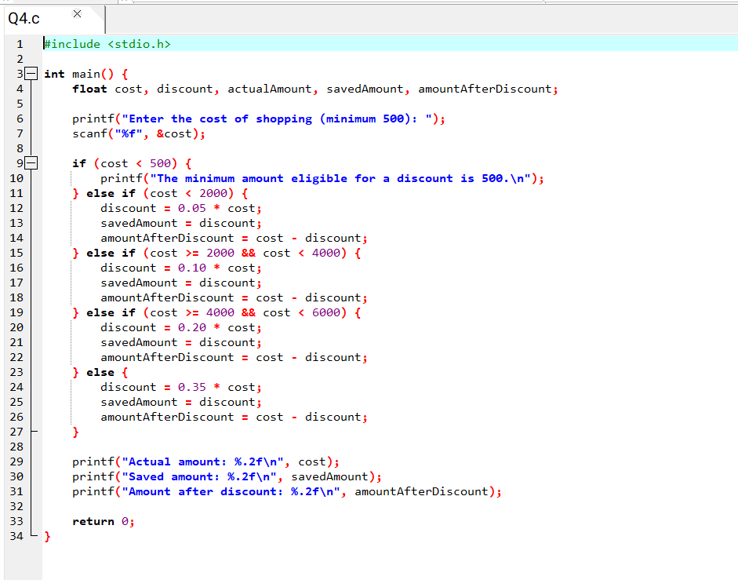

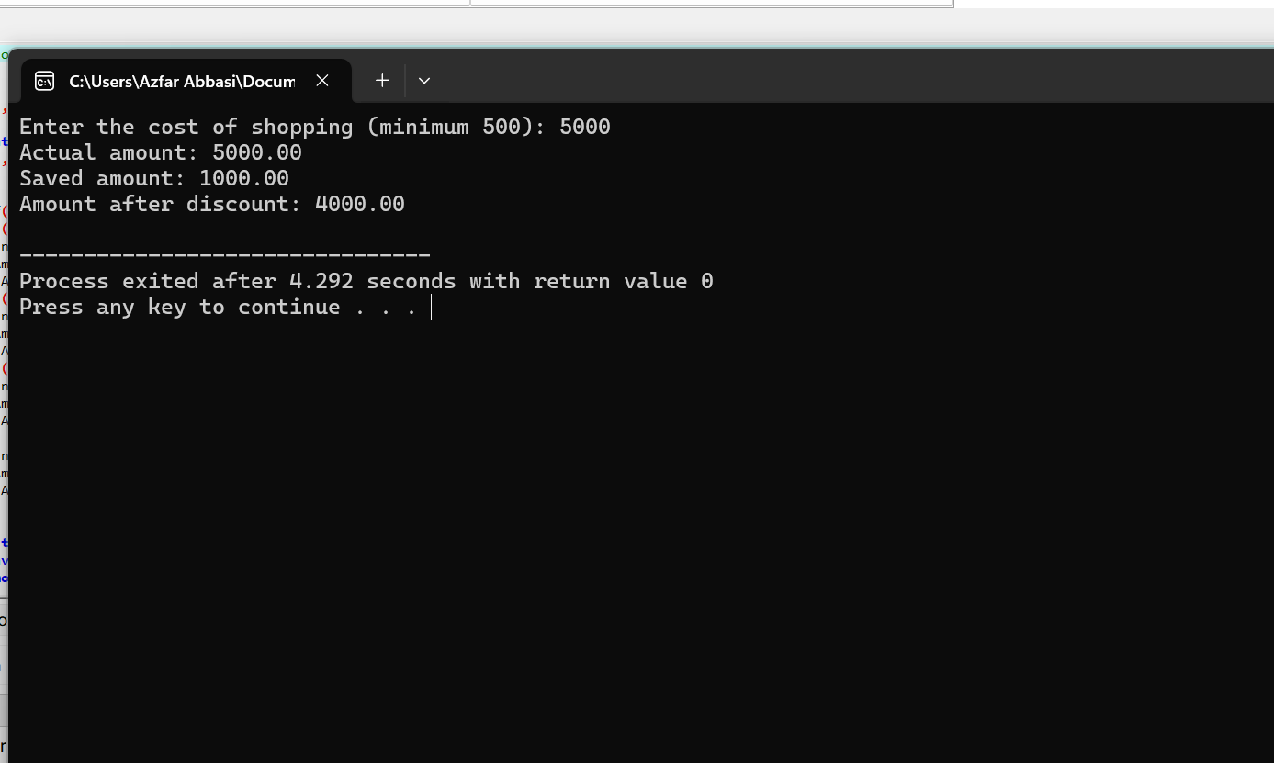

Question 5

Question 6   
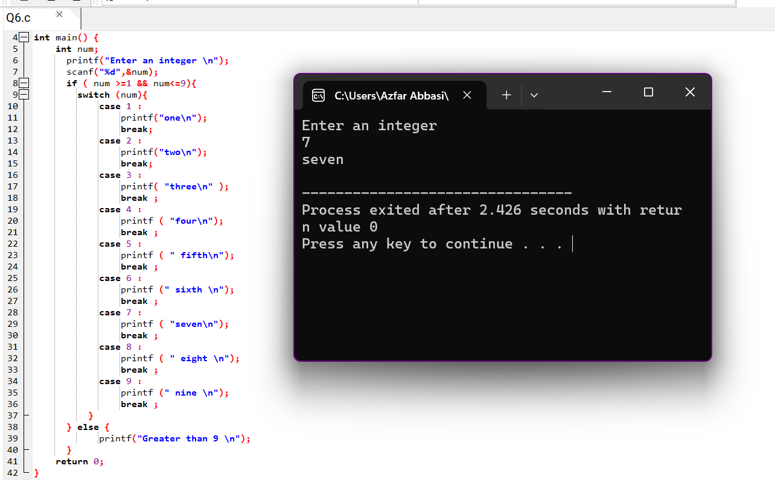

Question 7   
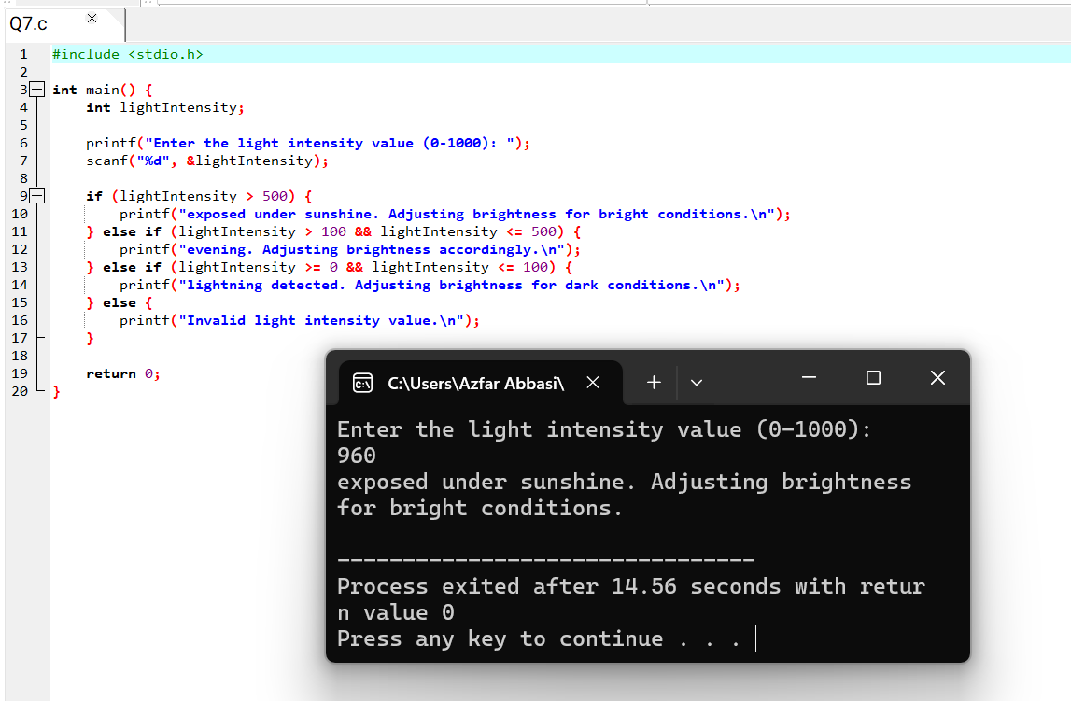

Question 8   
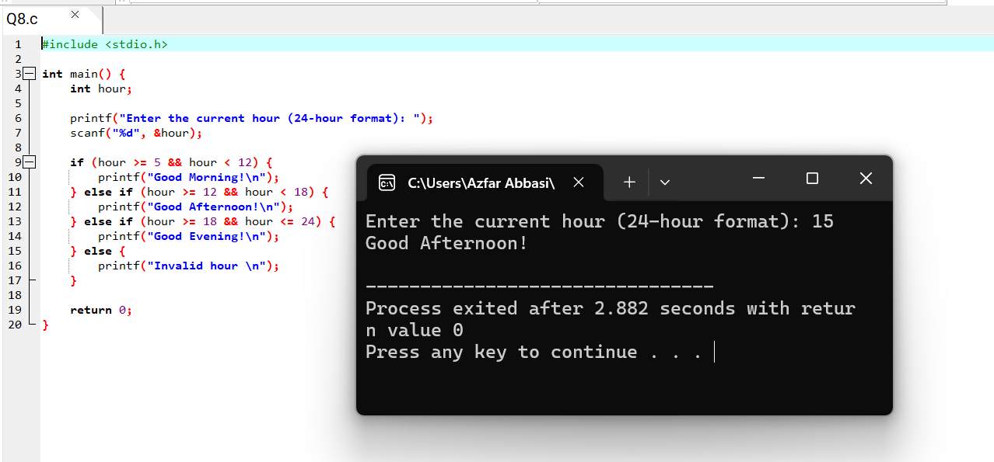

Question 9   
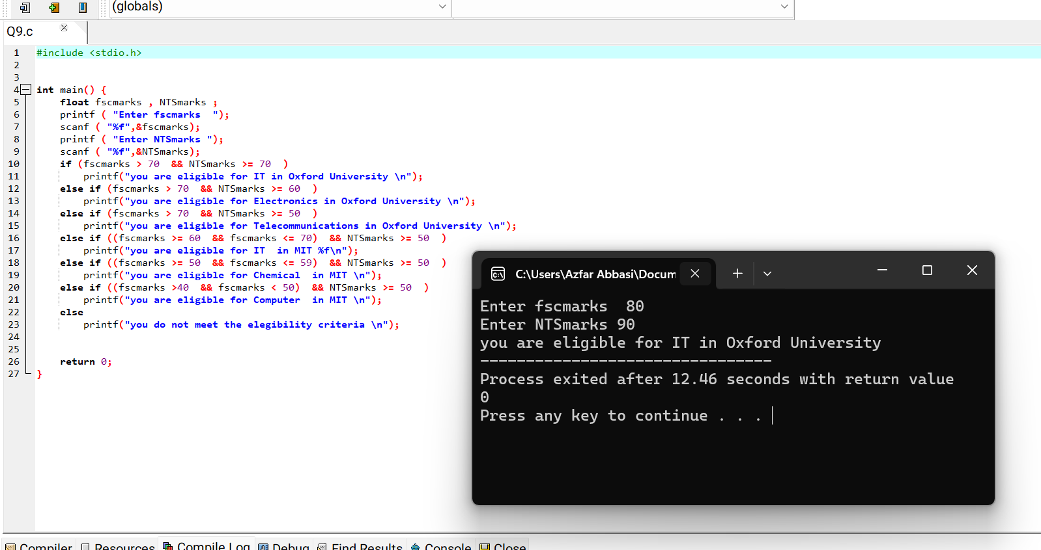

Question 10   
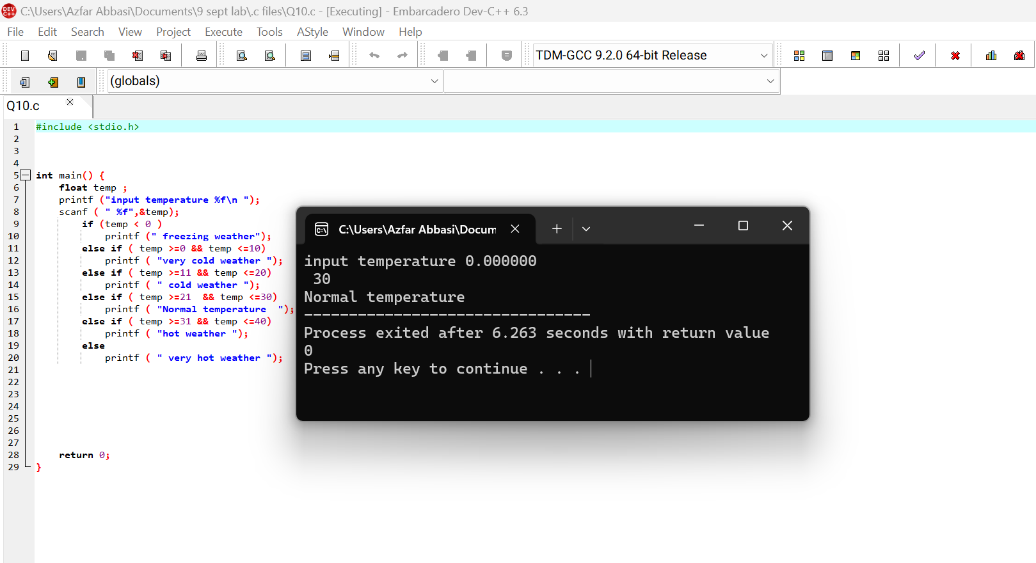

FlowCharts   
  
Question 2  
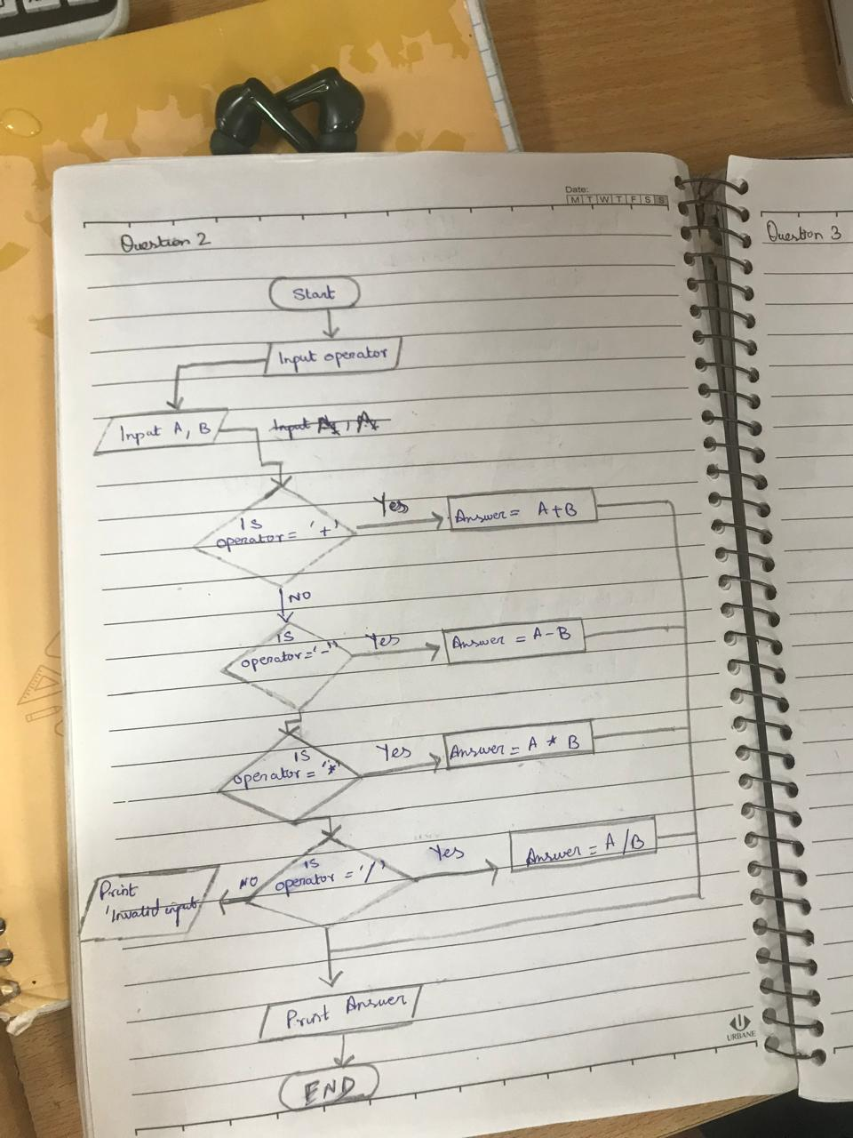

Question 3   
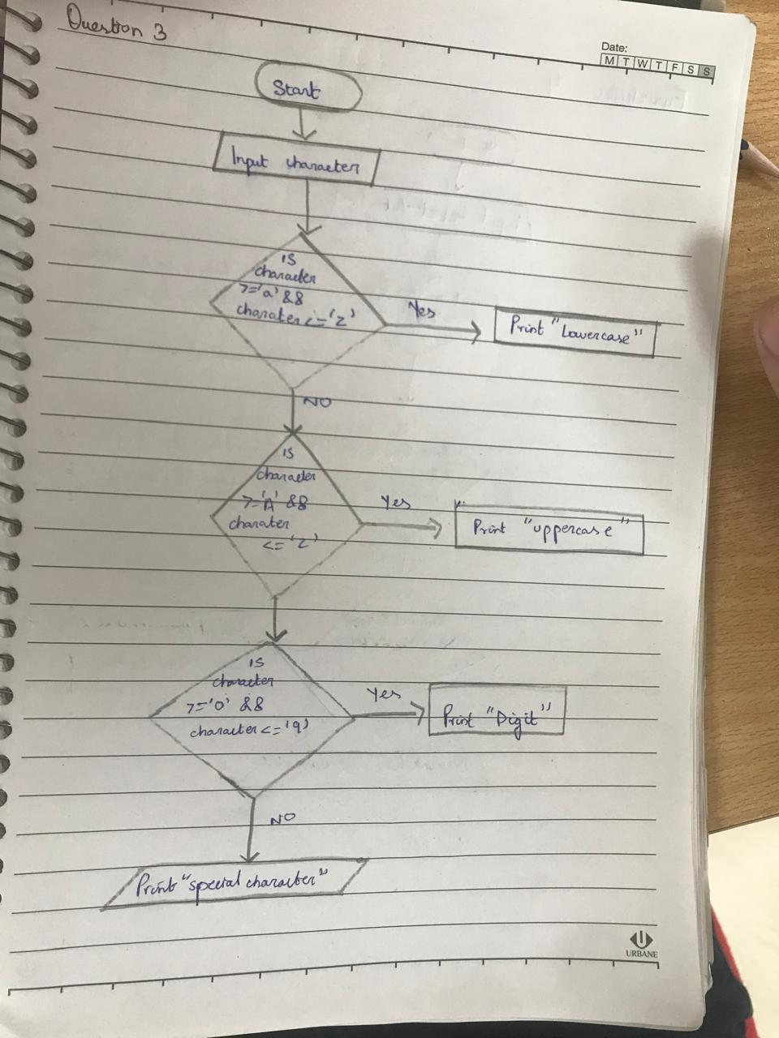

Question 4   
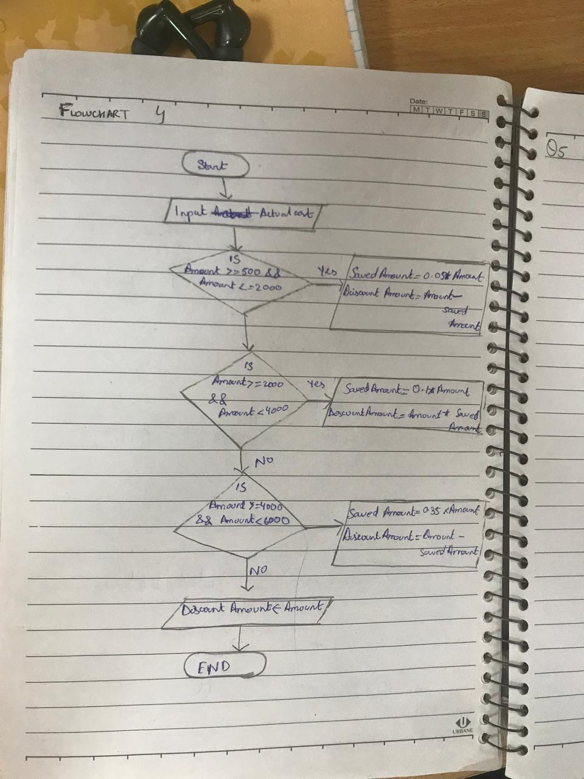

Question 5

